Git Basic Commands:

if user login into git at first time , we need to create this things.

$ git config --global user.name "John Doe"
$ git config --global user.email johndoe@example.com
we can check user

git config --list –show-origin
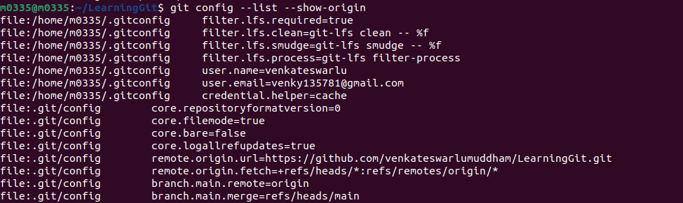

here we can see the path also where this files are stored.

git config user.name
git config user.email

git config --list
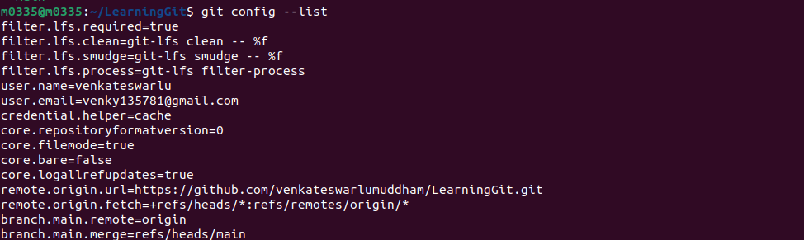
To set main as the default branch name do:
$ git config --global init.defaultBranch main

Getting Started - Getting Help
$ git help <verb>
$ git <verb> --help
$ man git-<verb>

git help config

git init

$ git add *.c
$ git add LICENSE
$ git commit -m 'Initial project version'

$ git clone https://github.com/libgit2/libgit2

Checking the Status of Your Files
The main tool you use to determine which files are in which state is the git status command. If you run this command directly after a clone, you should see something like this:
$ git status
On branch master
Your branch is up-to-date with 'origin/master'.
nothing to commit, working tree clean

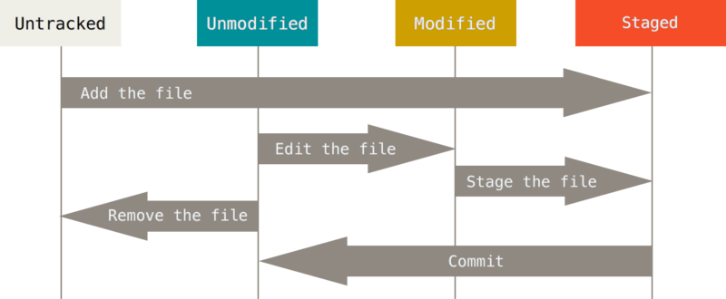

git add README

Git statings:

types:

modified , staging ,commit

vim CONTRIBUTING.md

$ cat .gitignore
*.[oa]
*~

# ignore all .a files
*.a

# but do track lib.a, even though you're ignoring .a files above
!lib.a

# only ignore the TODO file in the current directory, not subdir/TODO
/TODO

# ignore all files in any directory named build
build/

# ignore doc/notes.txt, but not doc/server/arch.txt
doc/*.txt

# ignore all .pdf files in the doc/ directory and any of its subdirectories
doc/**/*.pdf

